MYCELIUM
Brand Identity – Company Definition – Strategic Narrative
Master Brand Document (Revised Version)

1. NAME ORIGIN AND MEANING
Why Mycelium
Mycelium is the underground biological network that connects entire ecosystems.
It enables:
- Nutrient exchange
- Information transfer
- System resilience
- Cooperative behavior across species
It is the most efficient distributed system ever evolved.
Mycelium is not a metaphor.
It is a proven operating model.

What Mycelium represents
Mycelium is:
- Distributed intelligence
- Invisible infrastructure
- Adaptive coordination
- Biological optimization
It does not rely on central control.
It relies on:
- Many nodes
- Continuous communication
- Local decisions
- System-wide optimization

Brand interpretation
Mycelium is both inspiration and model.
There is no longer a distinction between:
- Nature (inspiration)
- Technology (implementation)
Mycelium becomes:
The blueprint for a new agricultural infrastructure.

2. COMPANY PURPOSE
Why Mycelium exists
Agriculture is entering a structural breakdown driven by:
- Labor shortage
- Aging operators
- Rising energy costs
- Climate instability
- Chemical dependency
- Economic fragility
The current model is:
- Centralized
- Capital intensive
- Mechanically dependent
- Operationally rigid
This model is failing.

The shift
The next evolution of agriculture is not:
- Bigger machines
- More inputs
It is:
Distributed, intelligent, autonomous systems
Nature already solved this.
Mycelium applies it.

3. THE CORE PROBLEM
A capacity crisis
Agriculture does not lack demand.
It lacks operational capacity.
Farms cannot:
- Operate continuously
- Access labor
- Manage costs
- Integrate technology

The five structural gaps
Labor gap
- Lack of operators
- Increasing costs
- Loss of skills
Accessibility gap
Farming requires:
- Physical effort
- Constant presence
This excludes:
- Elderly
- Part-time operators
- New entrants

Machinery gap
Current machinery is:
- Oversized
- Expensive
- Underutilized

Energy gap
Dependence on:
- Diesel
- Grid instability
Energy is now a constraint.

System gap
Agriculture lacks:
- A unified operating system
- Interoperability
- Data integration

4. THE MYCELIUM APPROACH
Core idea
Mycelium does not build machines.
Mycelium builds:
Autonomous agricultural ecosystems

System logic
Instead of:
- One large machine
Mycelium enables:
- Many small intelligent units
Working as a network.

Key principle
Agriculture as a living system, not a mechanical process

5. TECHNOLOGY PILLARS
Distributed robotic nodes
Small, modular, electric platforms:
- Low impact
- Continuous operation
- Remote supervision
- Scalable

Energy as infrastructure
Energy becomes:
- Distributed
- Integrated
- Autonomous
Includes:
- Batteries
- Wireless charging
- Energy hubs
- Renewable integration

Digital coordination layer
Mycelium OS
Enables:
- Fleet coordination
- Task allocation
- Energy optimization
- Remote control

Data layer
Continuous learning through:
- Field data
- Machine data
- Energy data
System improves with scale.

6. PRODUCT ARCHITECTURE
Ecosystem structure
Company:
Mycelium
Platform:
Mycelium Network
Software:
Mycelium OS
Robotics:
Mycelium Nodes
Fleet logic:
Mycelium Swarm
Energy:
Mycelium Energy
AI:
Mycelium Intelligence

7. POSITIONING
What Mycelium is NOT
- Not a tractor company
- Not a robotics startup
- Not a machinery supplier

What Mycelium IS
An agricultural infrastructure company

Definition
Mycelium builds:
- Infrastructure
- Systems
- Ecosystems
Not products.

8. CATEGORY
New category
Autonomous Regenerative Agricultural Infrastructure

9. VISION
Vision
Transform agriculture into:
- Autonomous
- Connected
- Regenerative ecosystems

Expanded
Enable:
- Energy independence
- Accessible farming
- Continuous operation

10. PURPOSE
Purpose
Accelerate the transition toward:
Regenerative, autonomous agriculture

11. SUSTAINABILITY
Five dimensions
Environmental
- Zero emissions
- Soil protection
Social
- Accessible farming
- Reduced physical effort
Economic
- Lower costs
- Higher efficiency
Energy
- Local production
- Off-grid capability
Ecosystem
- Integration with nature
- Selective operations

12. STRATEGIC NARRATIVE
Nature already built the system.
We apply it.

From:
Biological networks
To:
Engineered ecosystems

13. BRAND ARCHETYPE
Primary:
The Architect
Secondary:
The System Builder

14. BRAND PERSONALITY
- Technical
- Minimal
- System-driven
- Credible
- Long-term oriented

15. VISUAL DIRECTION
- Magenta as core color
- Dark technical backgrounds
- Network geometries
- Organic + engineered fusion

16. LOGO PRINCIPLE
The logo represents:
- A node
- A network
- A root system
Unified in one symbol.
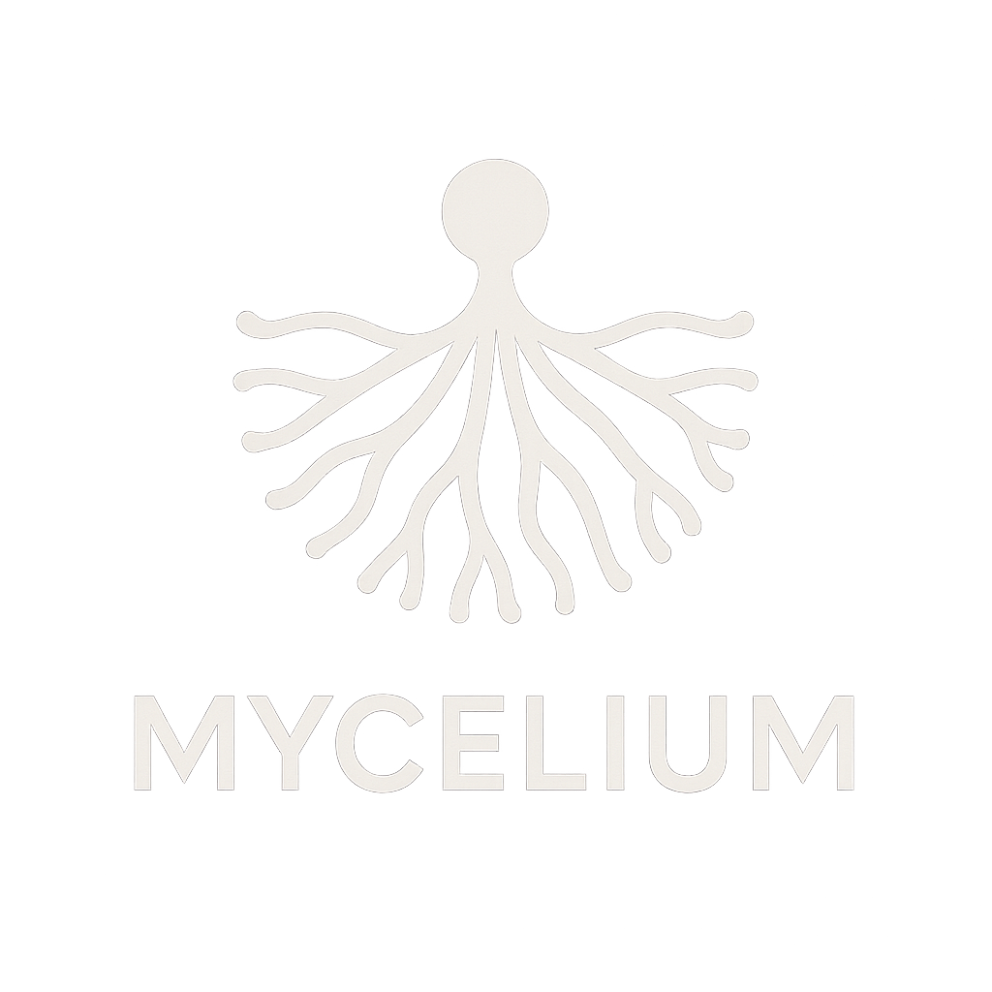 WORK in PROGRESS…

17. TAGLINE
Primary
The operating system of regenerative agriculture

Alternatives
- Agriculture as a living network
- Infrastructure inspired by nature
- Small nodes. Intelligent systems

18. FINAL BRAND ESSENCE
If Mycelium is how nature builds ecosystems,
Mycelium is how we build the future of agriculture.

